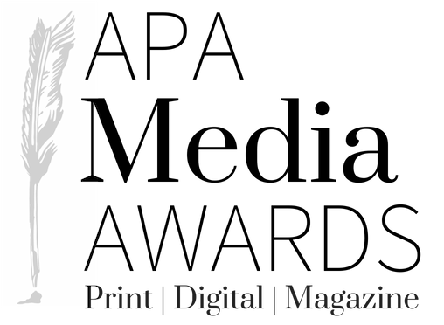

FOR RELEASE: Saturday, June 29, 2019
Contact: Jaclyn Langan
(205) 871-7737

APA Media Awards Magazine Contest Winners Announced

Birmingham, AL (June 29, 2019) – Select winners of the 2019 Alabama Press Association Media Awards were announced by Dee Ann Campbell, chairman of the AMA Contest Committee. This year, 90 publications submitted 3,394 entries in the annual contest. The Illinois Press Association membership judged the entries.

The awards were presented on Saturday, June 29 at the 2019 APA Summer Convention at the Perdido
Beach Resort in Orange Beach, AL.

The awards for Magazine of the Year and Best Overall Design were also announced and presented at the awards banquet on June 29, 2019, along with select other AMA contest winners.

Congratulations to all of the winners

Cat. 01 Magazine of the Year
1st Place Tuscaloosa magazine
2nd Place Birmingham magazine
3rd Place LAKE Magazine

Cat. 02 Best Single Feature Story
1st Place: Homewood Life for “Homewood’s Gentleman’s Quarter” by Melanie Peeples
2nd Place: Edible Lower Alabama for “For One Night, the Bad Boy Chefs of Alabama Clean Up Real Nice” by Alyson Sheppard
3rd Place Alabama Magazine for “All Creatures Great and Small” by Bishop Chavers, Steve Millburg, Art Meripol

Cat. 03 Best Personality Profile
1st Place: Tuscaloosa magazine for “No. 2 Ruby Battles” by Kelcey Sexton
2nd Place: Vestavia Hills Magazine for “A Force of Nature” by Melanie Peeples
3rd Place: Tuscaloosa magazine for “Great Scott! A Culinary Star Shines in Marion” by Donna Cornelius

Cat. 04 Best Business Feature
1st Place Edible Lower Alabama for “An Oyster for All Seasons” by staff
2nd Place Birmingham magazine for “Ship It to Me” by Jeremy Burgess
3rd Place Tuscaloosa magazine for “Bourbon Street comes to Brown's Corner” by Donna Cornelius

Cat. 05 Best Photo Essay
1st Place Alabama Magazine for “Traveling New Roads” by Bishop Chavers, Kree Middleton, Larry Bell
2nd Place Selma, the magazine for “Clay Baker” by staff
3rd Place Elmore County Living for “John B. Scott Trail” by Kenneth Boone

Cat. 06 Best Single Photograph
1st Place Edible Lower Alabama for “Portrait of Erin Childress, owner of Farm Fresh Meats butcher shop” by staff
2nd Place Jackson Monthly for “Adventure by Kayak” by Kevin Terrell, Elizabeth Law
3rd Place Shelby Living for “New Crops in Familiar Places” by Dawn Harrison

Cat. 07 Best Individual Website
1st Place Peach Living (peachlivingmagazine.com)
2nd Place Madison Living (madisonlivingmagazine.com)
2nd Place Homewood Life Magazine (homewoodlife.com)

Cat. 08 Best Single Ad
1st Place walker magazine for “City of Jasper Foothills Festival 2018” by Malarie Brakefield
2nd Place Tuscaloosa magazine for “Townsend Nissan” by staff
3rd Place Homewood Life “Ditsy Daisy” by staff

Cat. 09 Best Advertising Campaign or Series
1st Place Selma, the magazine for “Safford Trading Company” by staff
2nd Place walker magazine for “City of Jasper” by Malarie Brakefield
3rd Place Tuscaloosa magazine for “Rumsey Environmental” by staff

Cat. 10 Best House Ad or Self-Promotion
1st Place Tuscaloosa magazine for “Subscribe and renew” by staff
2nd Place Tuscaloosa magazine for “Amazing Teachers” by staff
3rd Place Peach Living for “Best of the Best” contest by staff

Cat. 11 Best Overall Design
1st Place Tuscaloosa magazine by staff
2nd Place Alabama Magazine by Bishop Chavers, Lane Gregory
3rd Place Birmingham Magazine by Nicole Gerrity, Ritu Parr

Cat. 12 Best Cover Photo or Illustration
1st Place Birmingham magazine for “Athlete” by James Acomb
2nd Place Jackson Monthly for “Farming for the future” by Elizabeth Law, Danielle Kirkland
3rd Place Tuscaloosa magazine for “Great Scott! A Culinary Star Shines in Marion” by staff

Cat. 13 Best Themed Issue
1st Place Birmingham magazine for “Beach Issue” (May)
2nd Place Homewood Life for “Homewood's Best” (May)
3rd Place Tuscaloosa magazine for “Crimson Dynasty” (January)

